How to install Jupyter Notebook in Windows?

Jupyter Notebook is an open-source web application that allows you to create and share documents that contain live code, equations, visualizations, and narrative text. Uses include data cleaning and transformation, numerical simulation, statistical modeling, data visualization, machine learning, and much more.

Jupyter has support for over 40 different programming languages and [Python](https://www.geeksforgeeks.org/python-language-introduction/) is one of them. Python is a requirement (Python 3.3 or greater, or Python 2.7) for installing the Jupyter Notebook itself.

Jupyter Notebook can be installed by using either of the two ways described below:

* **Using Anaconda:**  
  Install Python and Jupyter using the Anaconda Distribution, which includes Python, the Jupyter Notebook, and other commonly used packages for scientific computing and data science. To install Anaconda, go through [How to install Anaconda on windows?](https://www.geeksforgeeks.org/how-to-install-anaconda-on-windows/) and follow the instructions provided.
* **Using PIP:**  
  Install Jupyter using the **PIP package manager** used to install and manage software packages/libraries written in Python. To install pip, go through [How to install PIP on Windows?](https://www.geeksforgeeks.org/how-to-install-pip-on-windows/) and follow the instructions provided.

**Installing Jupyter Notebook using Anaconda:**

Anaconda is an open-source software that contains Jupyter, spyder, etc that are used for large data processing, data analytics, heavy scientific computing. Anaconda works for R and python programming language. Spyder(sub-application of Anaconda) is used for python. Opencv for python will work in spyder. Package versions are managed by the package management system called conda.

To install Jupyter using Anaconda, just go through the following instructions:

* **Launch Anaconda Navigator:**  
  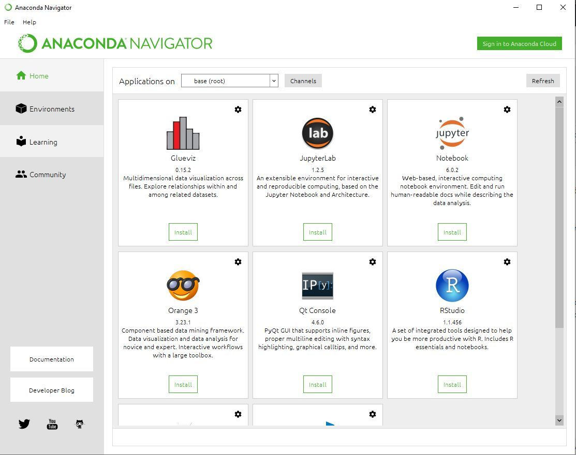
* **Click on the Install Jupyter Notebook Button:**  
  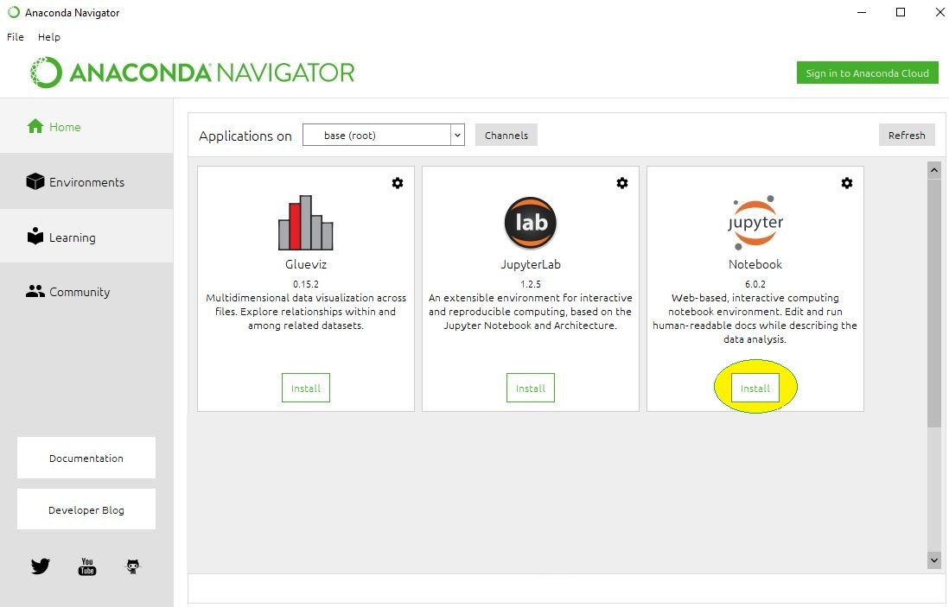
* **Beginning the Installation:**  
  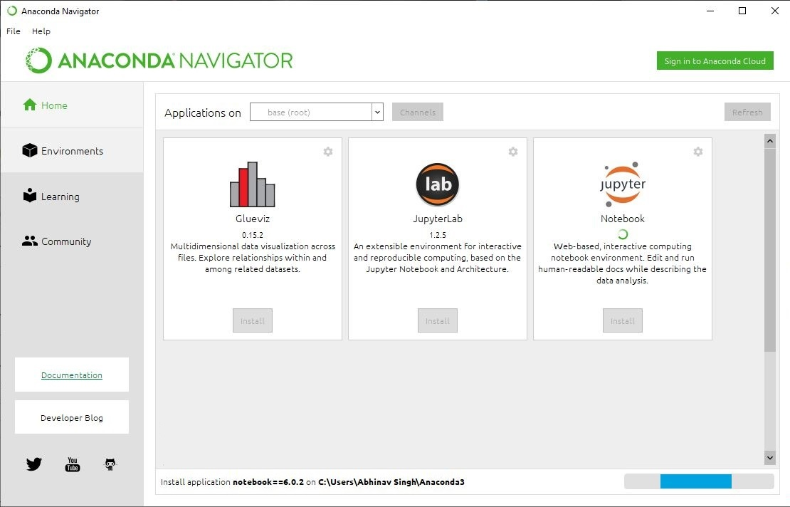
* **Loading Packages:**  
  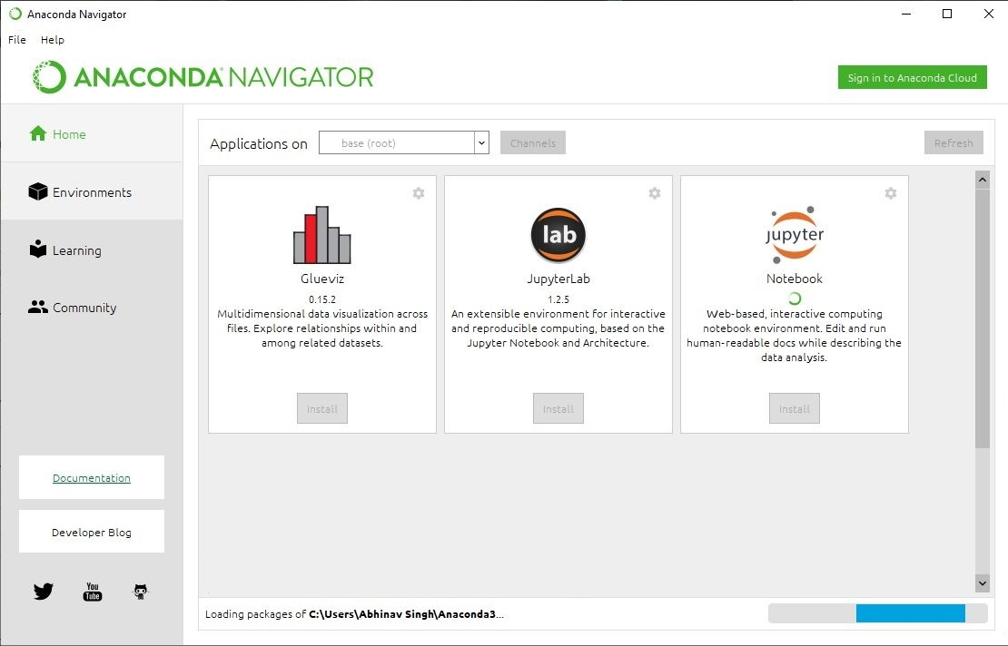
* **Finished Installation:**  
  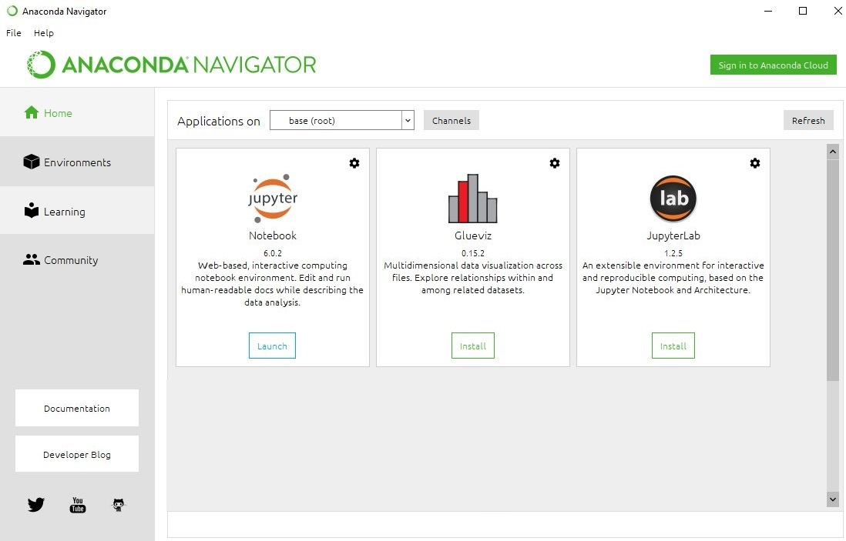

**Launching Jupyter:**  
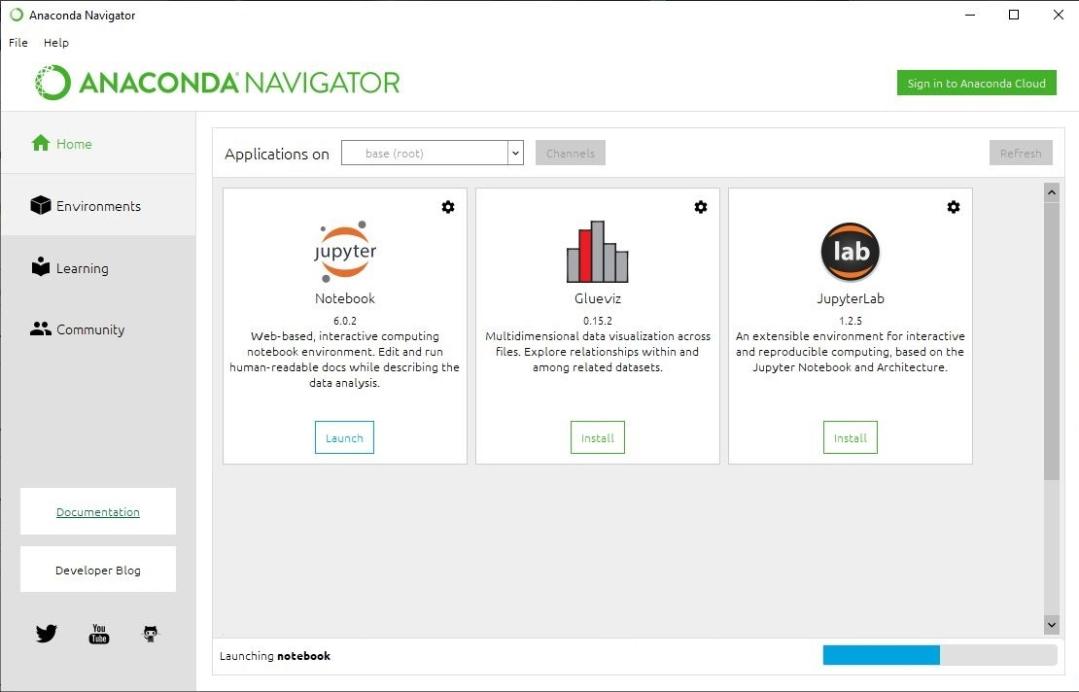

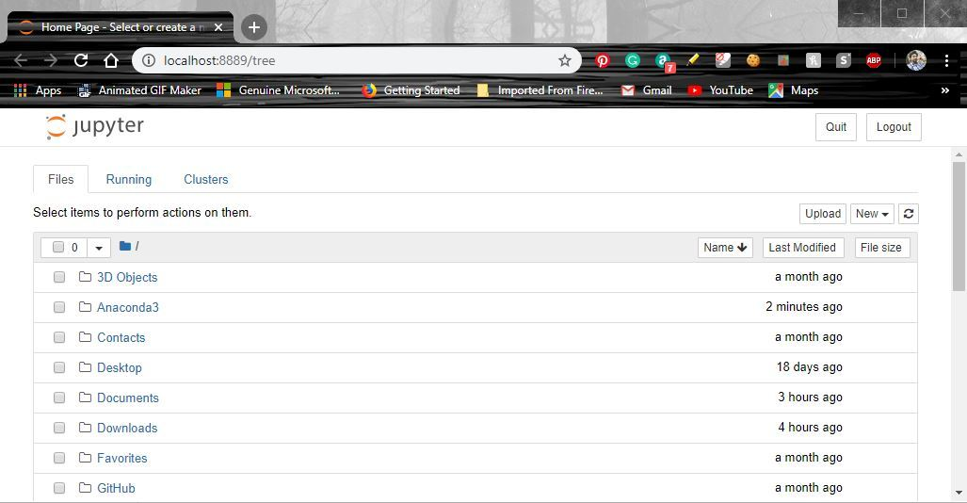

**Installing Jupyter Notebook using pip:**

**PIP** is a package management system used to install and manage software packages/libraries written in Python. These files are stored in a large “on-line repository” termed as Python Package Index (PyPI).  
pip uses PyPI as the default source for packages and their dependencies.

To install Jupyter using pip, we need to first check if pip is updated in our system. Use the following command to update pip:

python -m pip install --upgrade pip

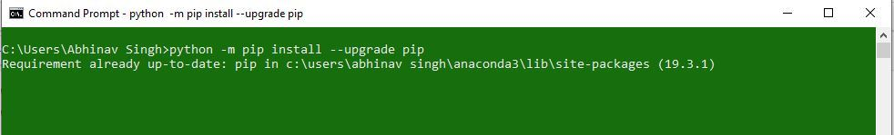

After updating the pip version, follow the instructions provided below to install Jupyter:

* **Command to install Jupyter:**
* python -m pip install jupyter
* **Beginning Installation:**  
  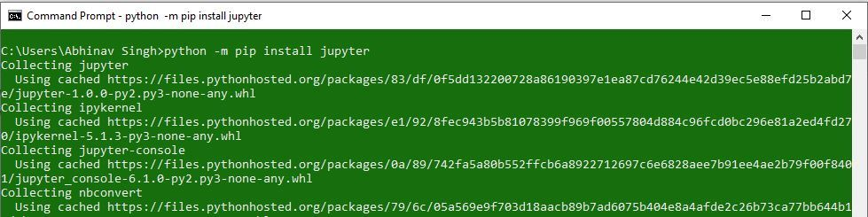
* **Downloading Files and Data:**  
  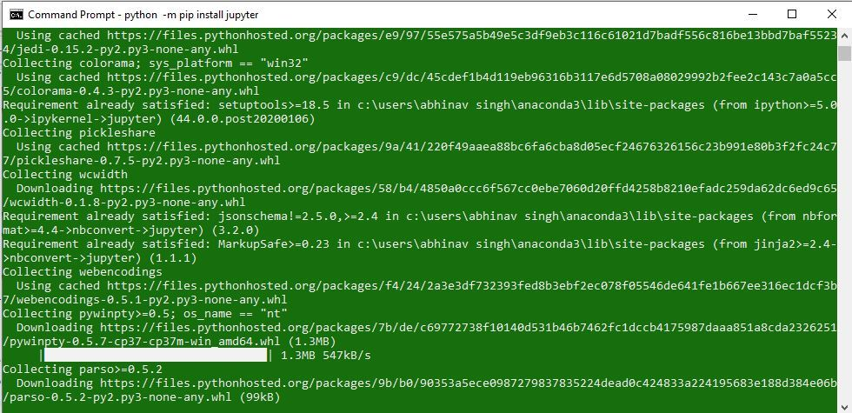
* **Installing Packages:**  
  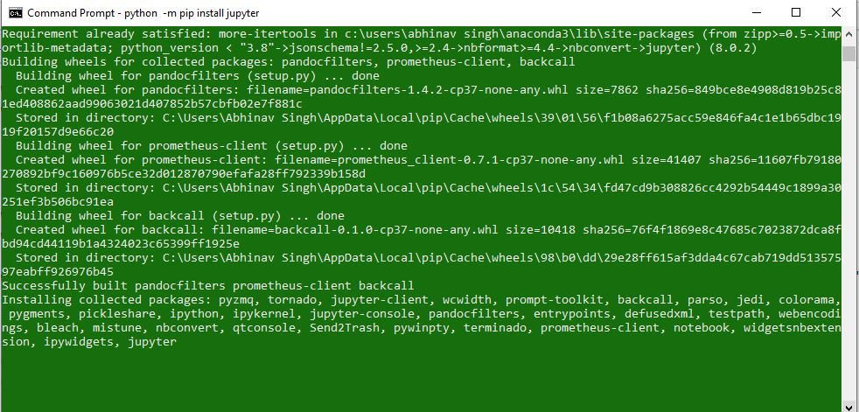
* **Finished Installation:**  
  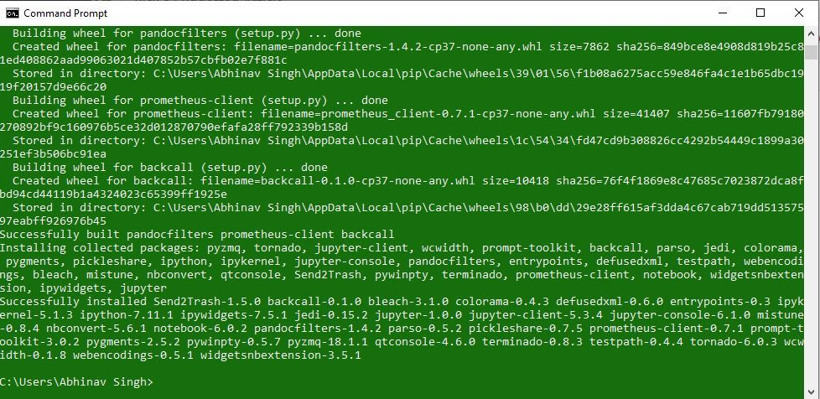

**Launching Jupyter:**  
Use the following command to launch Jupyter using command-line:

jupyter notebook

